**Survival Brainstorming**

- Games for reference:

The long Dark (Sleep, Exhaustion, Cold, Hunger..)

NEO Scavenger (Injuries, Diagram of the body, bandages, inventorysystem..)

7 days to die (crafting, disassembling of weapons)

Dont starve (day/nightcycle)

**Gamemechanics**

- its important that the player is able to see his own body

- day/night cycle

Since the length of day and night varie accordingly to the seasons, they dont have to be of the same length.

First idea: Day 30 minutes, dusk 10, night 10, dawn 10

- zones

The gameworld can be build out of zones. Zones have parameters like coverage from light, from rain, distance for line of sight (los), difficulty of the terrain, stresslevel, chance for injurie, chance to find something etc.

Example: Deep forest has a high coverage against light and rain, short distance for los, medium difficulty, low chance of injurie, high chance to find leaves and twigs and fruit and medium to high stresslevel

A clearcutting in the forest has zero coverage against rain and light, long distance for los, high difficulty, high chance of injurie, high chance to find pieces of wood and low stress level

- Injuries

Injuries will be shown to the player on a screen he can call up.

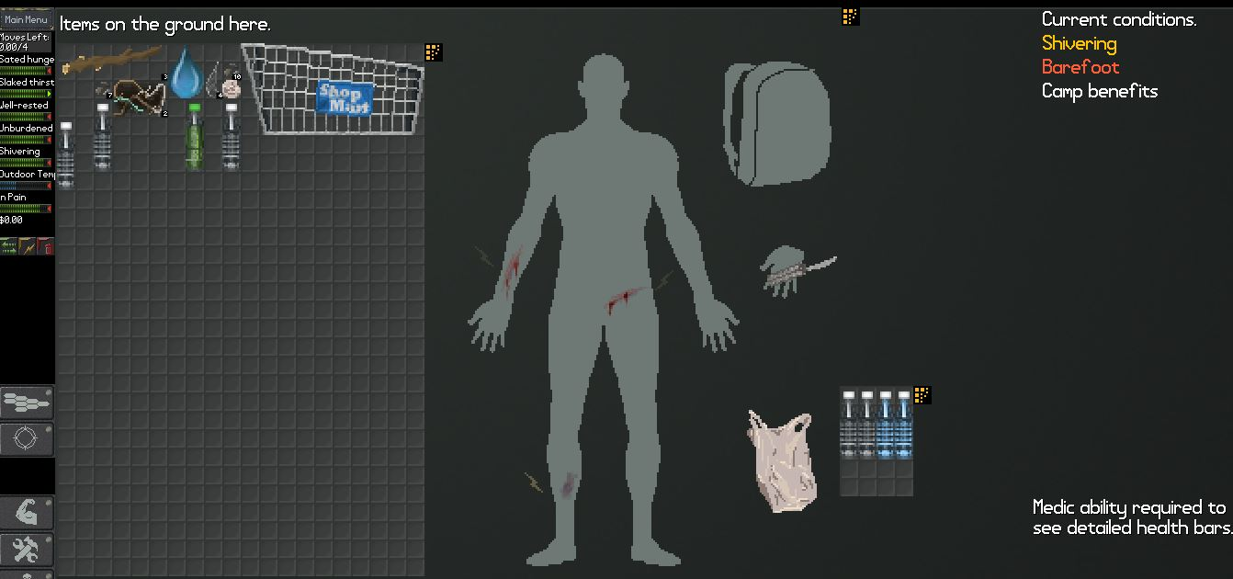It shows him his body and the region where the injuries are and any details the player can get with his skill in medicine.

Also on this screen he can select how he wants to treat the wound.

Note: Some injuries (like on the back) will require a second person to treat them right. This makes getting some allies extremly important.

- learning/adaptation

Humans are excellent at adopting to different situations, given enough time.

That is something the game should reflect in its mechanics.

Mechanics that can be influenced by learning/adaptaion are crafting, movement, stressresponse and resistance

Example crafting: The first tools the player crafts will be of very low durability and efficienzy. But with each new try they will improve because the character will iron out the flaws and think of new ways to improve them. This will also reduce the time it takes to craft that item.

Example movement: The first time the player moves into a new territory/zone, his movement will be reduced because it is unfamiliar to him. In addition his stress will rise because he is of course aware of the fact that he does not know where he is moving into.

But the longer he stays and the more often he takes that route, the more familiar he will become with the terrain, he will know where to place his feet and thereby increase his speed and reduce the chance of injuries

- ladder of success

During the game there should be a progression of steps of success which the player can achieve. Since the overall goal (being? Save your friends and escape? Kill the bad guy? Call in help?) is of course not easy to achieve, its important to give the player other things he can achieve to keep him motivated

Example

Step 0

the player is on the run, his pursuers hard on his heels through the jungle.

Goal: lose the pursuers

Step 1

The hunters have given up (for the moment), the player is alone in the jungle.

Goal: find any sort of shelter

Step 2

The player has found a nice spot for his first basecamp. Might be spot of flat ground near a lake/river, a rock, tree with clear ground beneath. There he gathers himself, checks what he has and what can be found in the immediat vicinity. It should become clear that, if he stays there for long, he will either be found or the environment will kill him

Goal: learn the basics of survival and crafting to prepare for a search for a better spot

Step 3

Equipped with primitiv gear and eating raw stuff to stay alive, the player starts to explore the surrounding jungle, looking for a spot that a) is better hidden and b) offeres better protection from the elements and options to set up more permanent utilities.

Examples: a have in a mountainside, a group of tress to build a treehouse, a dead, hollow tree. To be able to use these the player must complete a simple task, like make a torch to scare some animals out of the cave or make a rope to climb up a tree.

Goal:find the spot for a permanent base and “unlock” it

Step 4

The player has achieve his first bigger success, he has found a place that not only hides him well from detection (unless he makes lots of noise and such of course), it also has valuable resources nearby (water for example) and offers good shelter from rain, heat, cold, animals…

Goal: set up all the utilities that are needed for basic survival, a permanent fireplace, a place to sleep, something to collect water, to prepare food, to warm up, to store stuff

Step 5

The base is established and the player no longer needs to worry all the time about his basic needs like food, water, shelter and sleep

Goal: Now is the time to realy think about ways how to confront the mercenaries, get intel, spy on them, help your friends…

That is just the basic structure. The is an option for a twist that can, if implemented right, be rather entertaining:

The player knows that his friends are in danger. So he does not have all the time to focus on his own struggle, he propably will try to do something about them without being totally prepared.

This may result in the following scenario:

The player has achieved step 3, but instead of looking for good shelter he uses his basic gear to head out for the camp of the mercenaries. He spots one of his friends doing some labor, not well guarded. He sneaks in, rescues him, maybe even manages to gather some gear before they are being detected. They have to flee (going back to step 0 of the ladder again).

Now the cycle resets, with a few twists:

a) the AI now knows the player is still alive, what his goals are and that he is somewhat equipped. So they will search now more aggresivly, maybe resulting in the player needing to abandon his first base

b) the player has all the knowledge he already optained + maybe some new gear

c) the players now has an ally who might help him

This cycle can be done a number of times. The next friend will already be guarded better and closer to the central camp but the player is a bit better prepared now + has help maybe.

A scenario for the end might be that the player with a small band of poorly equipped followers need to free the last hostage against an enemy that is still more powerful but already weakened too.

- Inventory

While designing the inventory system its important to design it in such a way that it stays at least somewhat close to reality.

Example: objects have not only different weight but also different sizes. A pack of matches does not take up as much space as an assault rifle.

Nice example for an inventorysystem has Neo Scavenger

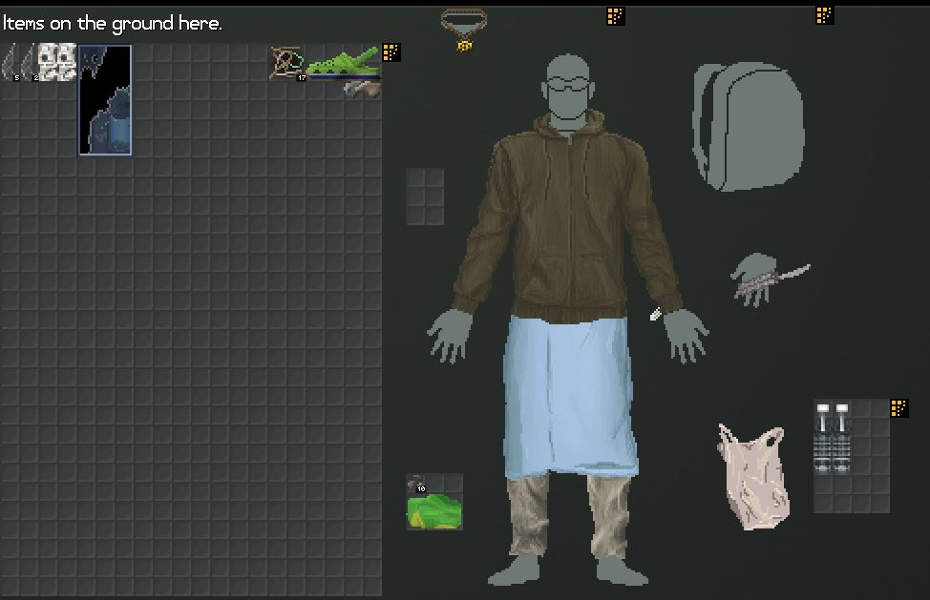

Items:

To establish a somewhat realistic inventory system, items need to have certain attributes

- weight

Carrying a heavy weight increases exhaustion fast. If the weight of an object is to high, it can not be moved, even if it is small enough to be picked up in theory.

- sizecategorie (tiny, very small, small, handsize, two-hands, large, very large, to big)

- “fits into/on” (pocket, hand, shoulder, backpack…

- “has handle” = yes/no

- stiff/adjustable

A piece of cloth can be stuffed almost everywhere, a hammer does not allow for its form to be changed, unless you wanna break it ^^

Example: A suitcase has the sizecategorie large, fits into “trunk”, “has handle = yes”.

So the player can wear it in one hand. If it is filled with Lead however, its weight is so high that the player cannot lift it at all.

A box of the same size with no handle requires both hands to be moved around

- Heat and cold and humidity

heat and cold can have severe impacts on our health and high humidity can be detrimental to our health too so that should be reflected in the game as well.

To protect against heat, cold and humidity, the player needs to equip certain types of gear, clothing that can shelter him. But most of the time, those things are only good against one thing and bad against the other so it may happen that the player needs to switch his gear according to where he wants to go. On the other hand, finding oneself in a situation one did not expect could result in severe problems. For example, the player is equipped to handle the heat of the day but is unable to reach his shelter before nightfall, the cold of the night might start to be a problem.

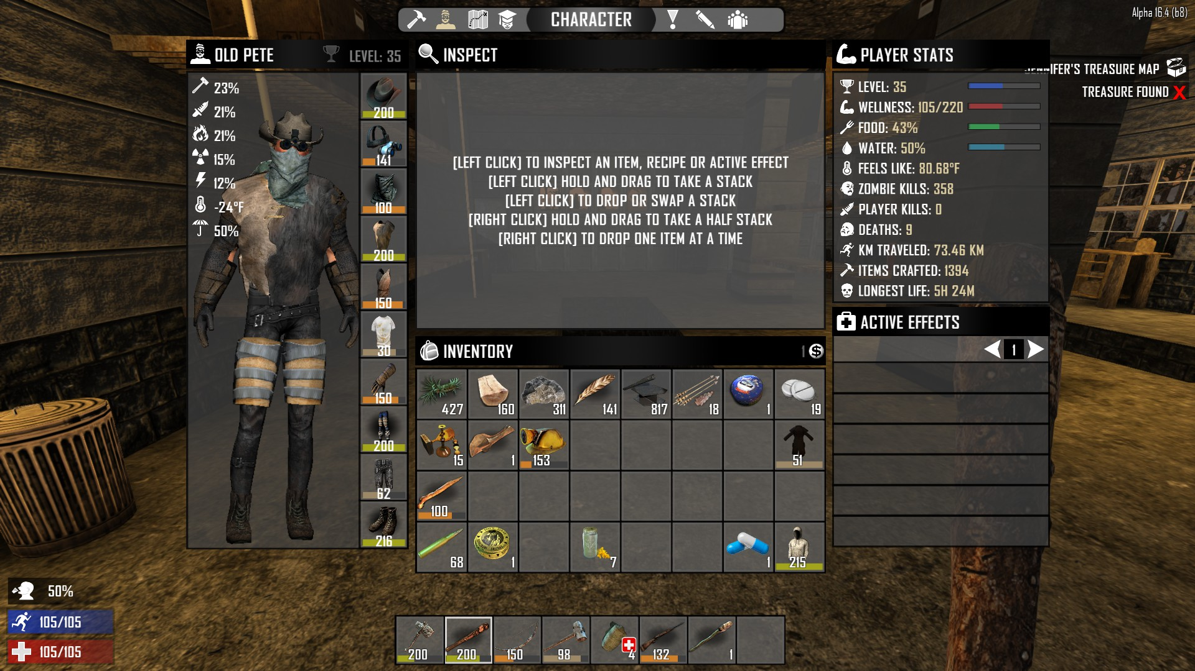Screenshot taken from 7 days to die.

On the left you can see the stats of the gear the character is wearing, the different types of protection it overs and also how well insulated he is. In this case the character is wearing gear that is good against cold, but since he is in a rather warm area he threatens to overheat.

- Pathfinding

If the player stays in an area for a while, he learns about the terrain and is able to move around faster. Also, if he travels between some spots often, he starts to remember the way (can result in the path being highlighted a bit)

Disadvantage: paths that are used often are easier to spot from the AI. There it may be useful to use the “cover track” action to reduce the chances for the AI to spot those tracks/paths

- Climbing

Climbing shall be as intuitive as possible. To achieve this, when the player wants to climb, the climbingskill of his avatar is compared to the climbing difficulty of the tree or wall or other object.

If his skill is below a certain threshold below the climbing difficulty, he cannot climb there at all. If his skill is above the threshold but still the target difficulty, climbing is possible but takes longer and drains more stamina and exhausts more.

If the skill is above the target difficulty, cllimbing is faster and drains less stamina

- crafting, assembling, disassembling, upgrading

Like with the guns in 7days to die, the player should be able to take stuff apart, especially stuff he did build. Unfamiliar items like a gun should require much more time and my result in failure if the character does not do it the right way.

But simple things like a simple spear, consisting of a long stick, a knife and something to tie it all up can be disassembled.

Example: the player crafts his first spear, which turns out rather shabby. He later founds a stronger rope and a better shaft, like the pole of a fence. He takes apart his old spear (returning the stick and the rope to his inventory) and uses the pole and the better rope to craft a new, better spear

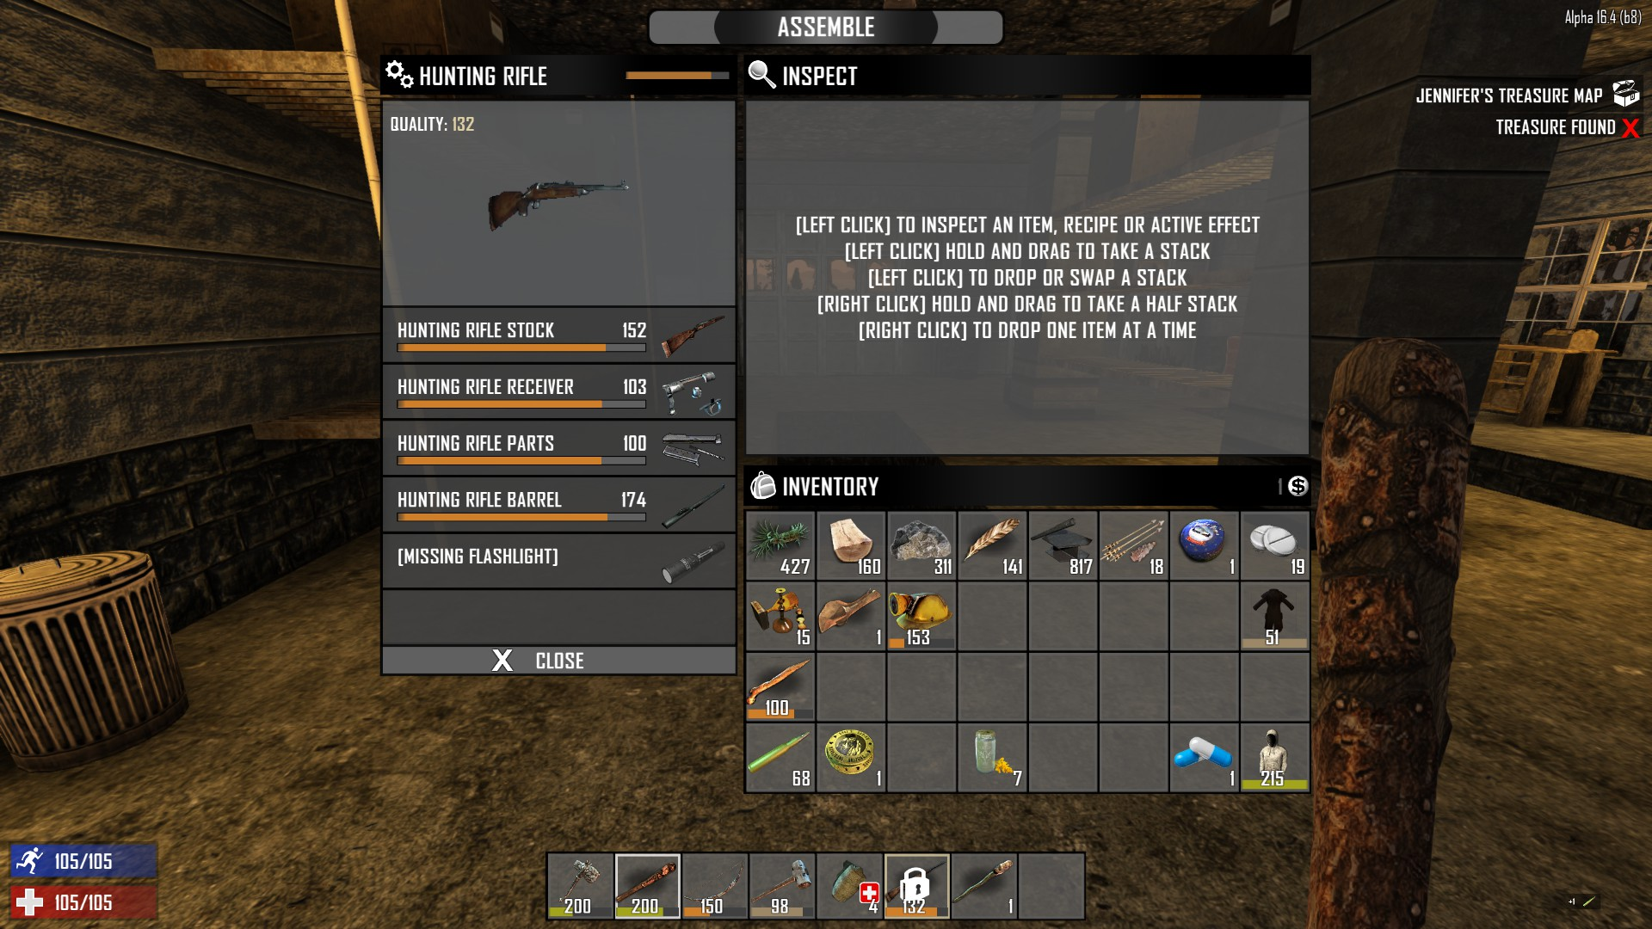

**AI**

They remember!

- The AI must NOT forget about the player if he hides for 5 seconds. They know he is out there!

Human enemies

- The opponents of the player are humans too. So they need to have a mood and character as well. Some may be more aggresiv, some cowards, some neutral. If hurt or outnumbered/trapped they might flee, drop their weapons, beg for mercy, go berserk, try to reason, to bribe.

They also share the same vulnerabilites, so will the player be able to shoot someone who broke his leg and is now screaming in pain?

What you see is what you get

- The AI must be lootable.

If the player manages to kill/take down one of the mercs who he saw using a radio, that guy must have this radio in his inventory. And looting includes everything, clothing, boots, helmet, belt, weapons… the mercs shall be a major threat but overpowering one also needs to be a big boost for the player, resulting in better gear and boosts for mood.

**Attributes of the avatar:**

Tiredness

As long as the characters are supposed to be normal people they have to sleep now and then. “The long dark” shows how tiredness and need for sleep can be included in a game without disrupting the gameflow.

Stamina

Stamina is connected to exhaustion. Stamina depletes and regenerates faster, but the more exhausted you are the less max stamina you have.

Example: The avatar runs 100m. At this point his stamina is at 0, overall exhaustion has dropped by a factor x. The avatar rests, his stamina regenerates up to the limit which is determined by his exhaustion. Now he can only run 90m before his stamina is depleted.

Exhaustion

Exhaustion is a factor that is limiting the player more than stamina. Exhaustion can only be reduced by a real rest, sleeping works best.

Mood

Success and other positive events have a positive effect on them mood, failure, injuries, disease ect, have a negative effect. A positive mood may result in a slight increase in action speed, higher chances of success on skillchecks, faster healing etc, while a low mood can cause the opposite effect on said events and actions.

Skills/abilities

Skills and abilities are values that are evaluated in the background while the avatar is doing things.

“learning by doing” is a key element in this regard.

Examples for skills and abilities:

- Athletics: is related to running, swimming, climbing and controlls how fast the avatar is losing stamina and gaining exhaustion while doing those physical activities)

- Climbing: the value of this skill is compared to the climbingdifficulty of for example a wall or a tree. If the skill of the avatar is much lower, the climbing is very slow or maybe not possible at all. If on the other hand he is a master climber, climbing is much faster

- medicine: governs the evaluation of wounds and injuries

- stealth: sneaking, moving quietly, the amount of tracks produced, the efficiency of the “remove tracks” action

- perception: spot tracks, traps, animals, items, rescources, etc.